**BACKGROUND**

The theoretical explanation for Least Squares Regression Analysis can be found in the Figliola text, Chapter 4 (1, p121). To fit a linear model, y = a0 + a1 x, to the selected experimental data sets (x1, y1), (x2, y2), …, (xN, yN) we can use the outcomes of the Example 4.9 in the text

**The Equations for Linear Least Squares Regression y = a0 + a1 x**

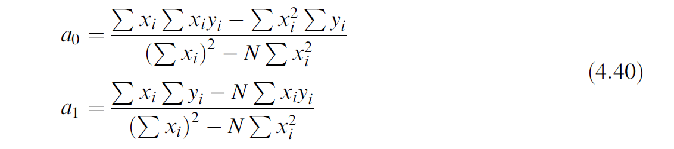

To determine the “goodness of fit” we can use the correlation coefficient, r, or the coefficient of determination, r2. The equation for the correlation coefficient is given below. Once r is calculated, the square of r, r2, is also known.

Correlation Coefficient

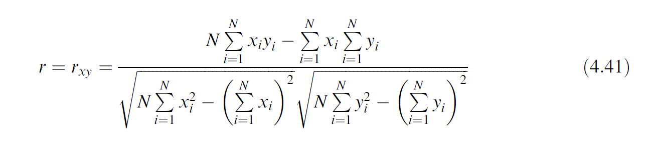

**Note on units:** for our Challenge 6, considering the data we are using from the calibration of the LVDT, the units for each coefficient will be

* Units for slope, a1 (mV/V) / cm
* Units for intercept, a0 (mV/V)

**BACKGROUND, cont’d**

Physical characteristics and sensitivity values for typical commercial LVDTs are shown below (2, p 395).

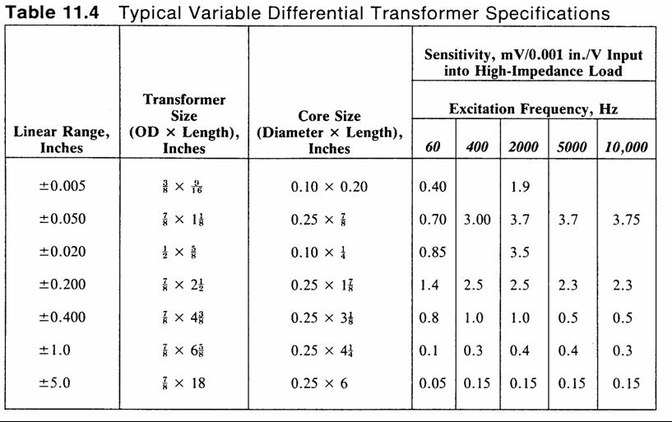

References:

1. R.S. Figliola and D.E. Beasley, Theory and Design for Mechanical Measurements, 7th Ed., Hoboken: Wiley, 2019.
2. T.G. Beckwith and R.D. Marangoni, *Mechanical Measurements*, 4th Ed., T, New York: Addison Wesley, 1990.